|  |  |  |  |  |  |
| --- | --- | --- | --- | --- | --- |
|  |  |  |  |  | logo1.png |

|  |  |  |  |
| --- | --- | --- | --- |
| Course Name | | Zoho Books | |
| College Name | | Mangayarkarasi College of Arts and Science for Women Paravai, Madurai - 625002 | |
| College Code | | MKU251 | |
| Skill Offering Id | |  | |
| Project Title | | Preparation and maintenance for zoho book of Dream Home Realty | |
| Project Submitted To | | Madurai Kamaraj University ( Naan Mudhalvan Scheme(TNSDC)) | |
| Year | | 2023 | |
| Department | | B.COM | |
| Semester | | 5 | |
| Group Number | | 6 | |
| Total Members of the Group | | 4 | |
| Group Members Details | | | |
| Name of the Member | University Register. No | | Student NM ID |
| T.Yogapriyadharshini | C1C15915 | | |  | | --- | | 94F56896080D0F2A3D347E864F4052D3 | |
| P.Vishali | C1C15913 | | |  | | --- | | 2224293EDC1258EA86A4854D00642C6B | |
| S.Pavithra devi | C1C15890 | | |  | | --- | | D84CB6551CDE1E09B1F4024E64FB97D4 | |
| M.Meenakshi | C1C15879 | | |  | | --- | | E5C6271106AFA10ABCA4D1BD3897BE0B | |
|  |  | |  |
| Under the Guidance | | MS.C.M Priyanka | |
| SPOC | | Ms.P.UMADEVI | |

**Analysing Housing Prices in Metropolitan areas in India**

1. **Introduction.**
   1. ***Overview***

**Dream Homes Realty, a construction company, uses Zoho Books to track project expenses, manage**

**subcontractor payments, and handle invoicing. They can generate estimates and invoices for clients,**

**track job costing, and monitor the profitability of each project. Zoho Books provides them with financial insights to make informed decisions.**

***1.2 Purpose***

* Before starting any search, have a clear idea of what you really want and what can be compromised. Start with visualizing the location and the neighborhood of your dream home. Decide where you want it to be, is it an urban location, busy streets, suburb, countryside, or any other location.
* Arguably the most important room when you purchase your dream home, a luxury bathroom will be a room in which you will be spending a large amount of time. Because of this, bathroom updates are incredibly important. In a room in which you will be using every morning and every night, luxury and comfort is key.

1. **Problem Definition and Design Thinking**

Empathy Map



**2.2 Ideation and Brainstroming Map**

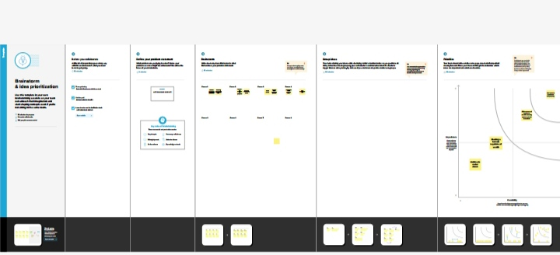

1. **Result:**

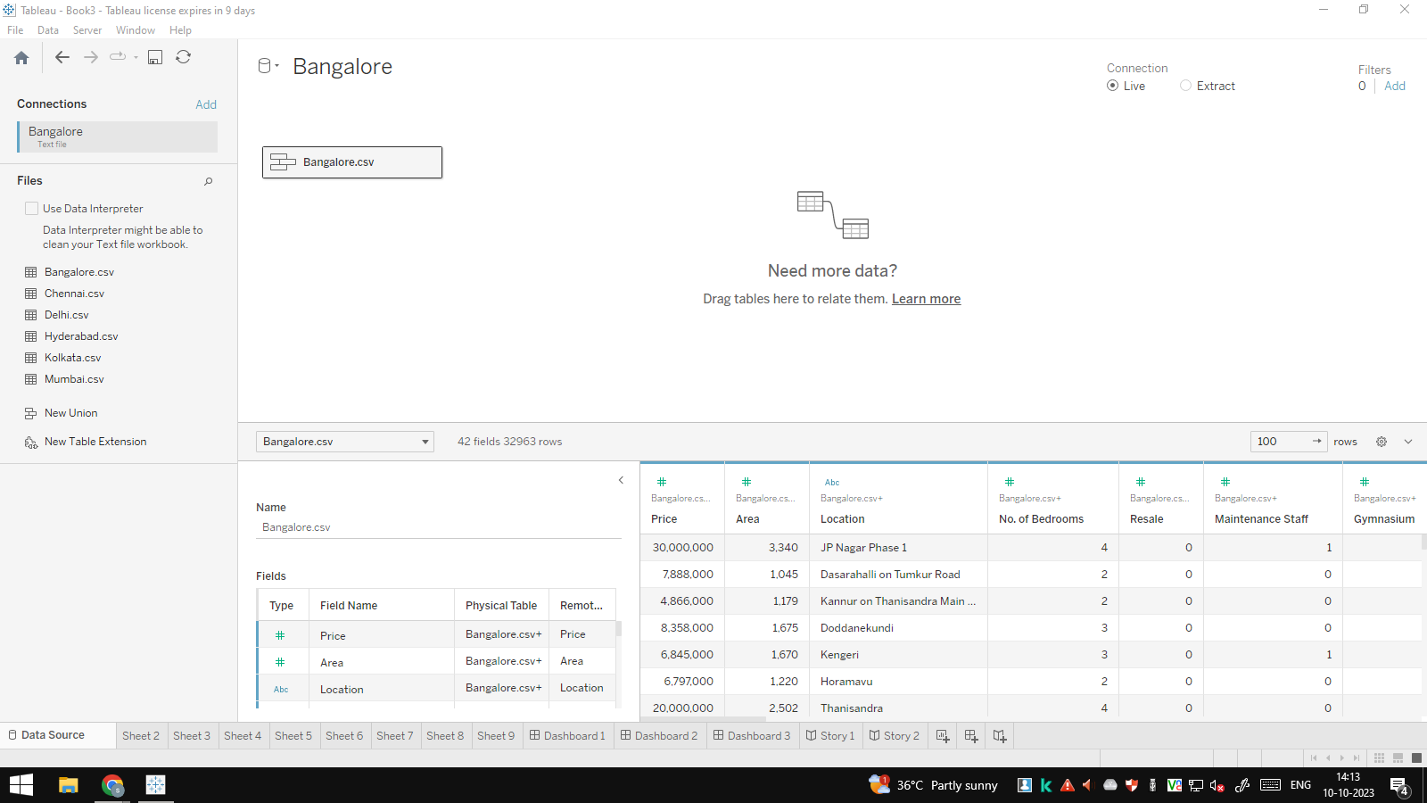

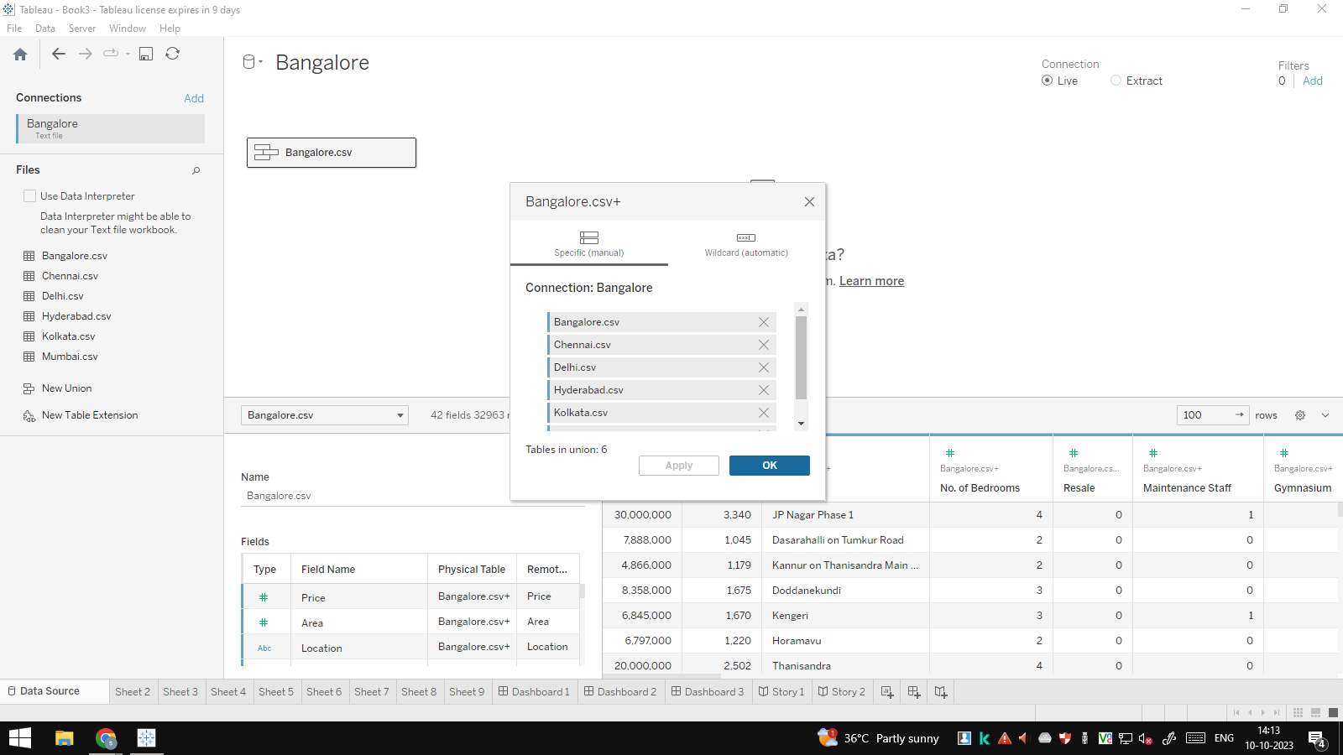

**Milestone 1: Set up your account**



**sign up for Zoho Books:**

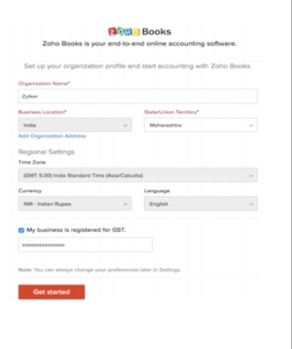

**Activity 2: Introduction**

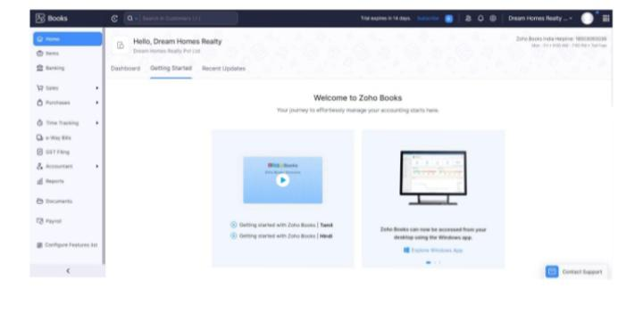

**Milestone 2: Service Creation:**

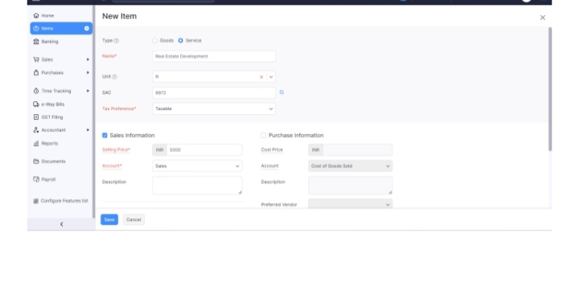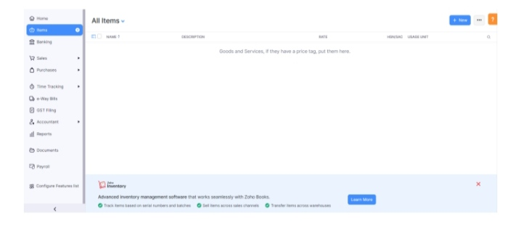

**Milestone 3: Vendors**

**Activity 1: Vendors Creation**

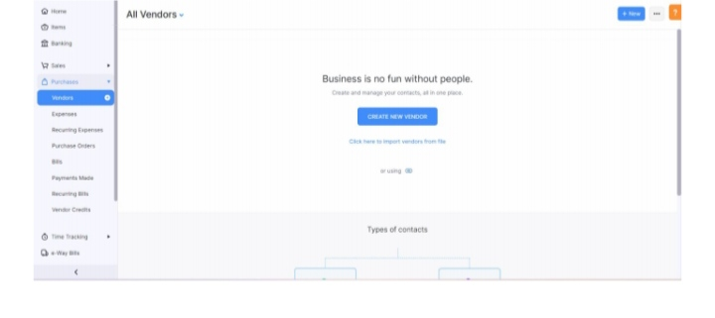

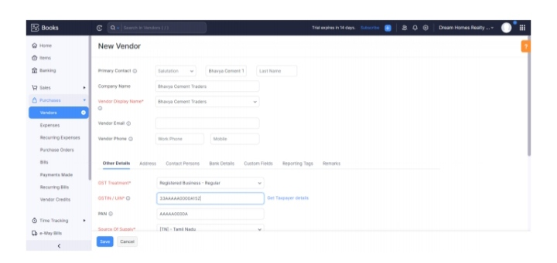

**Activity 2: Review of Vendors List**

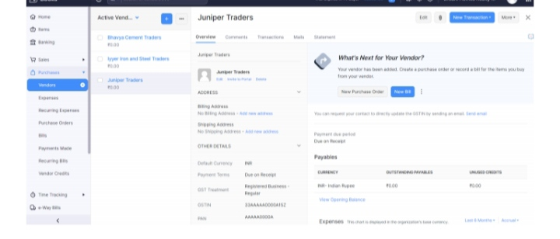

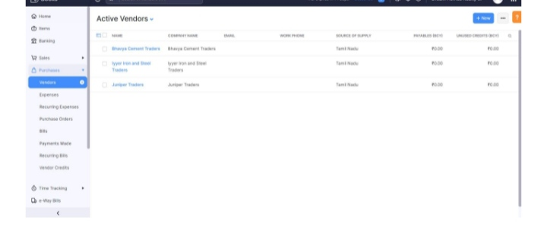

**Milestone 4: Purchases**

**Activity 1: Purchase Order creation**

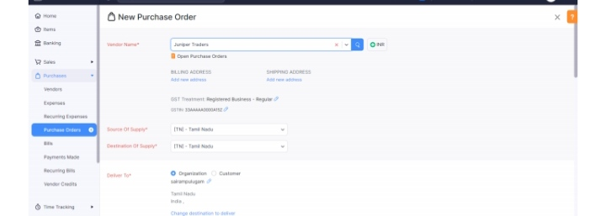



**Activity 2: Purchase Order to Purchase Bills Convertion**

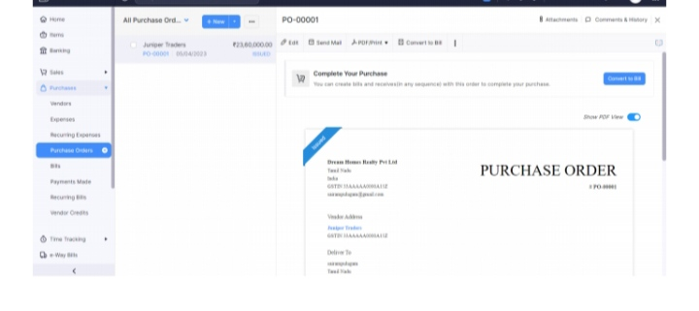

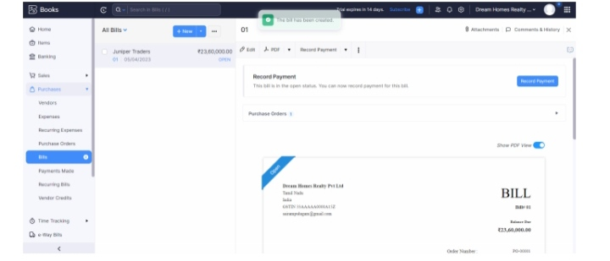

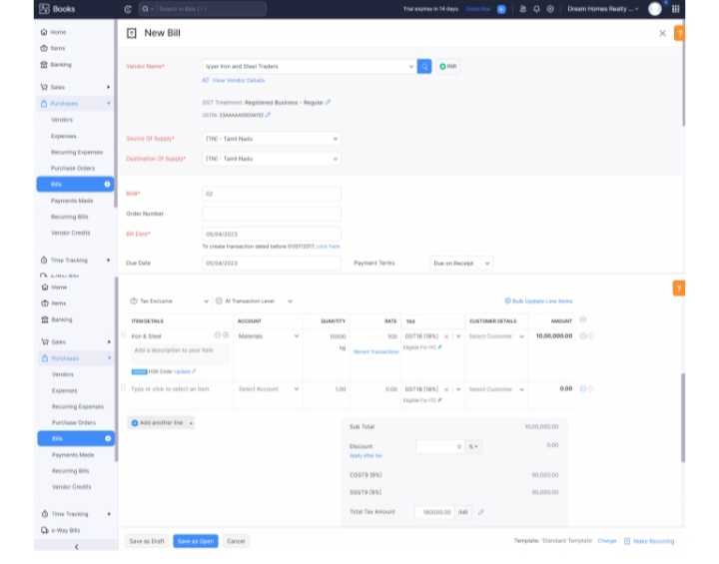**Activity 3: Direct Vendor Purchases Bills Creation:**

**Activity 4: Reconciliation of Open & Outstanding Bills**

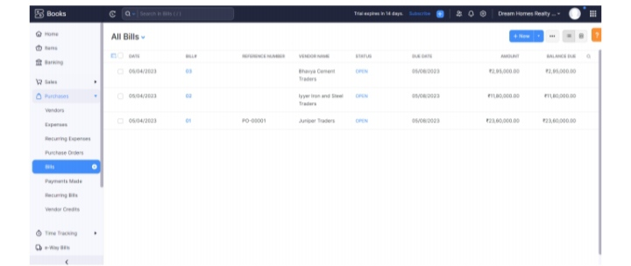

**Milestone 5: Customers**

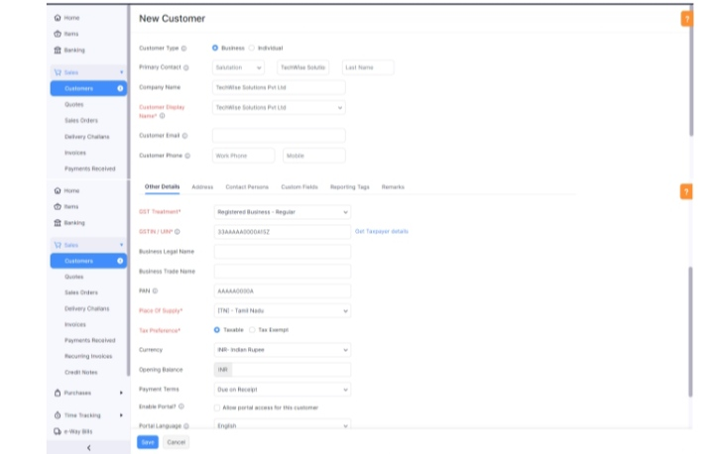

**Activity 2: Review the Customers List**

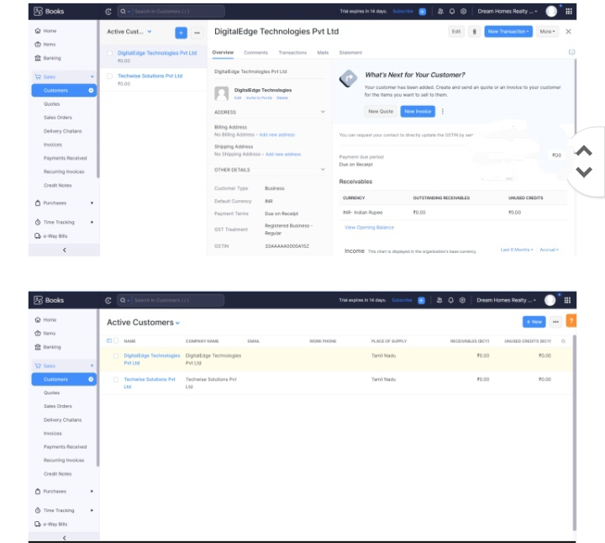

**Milestone 6: Sales**

**Activity 1: Sales Order Creation**

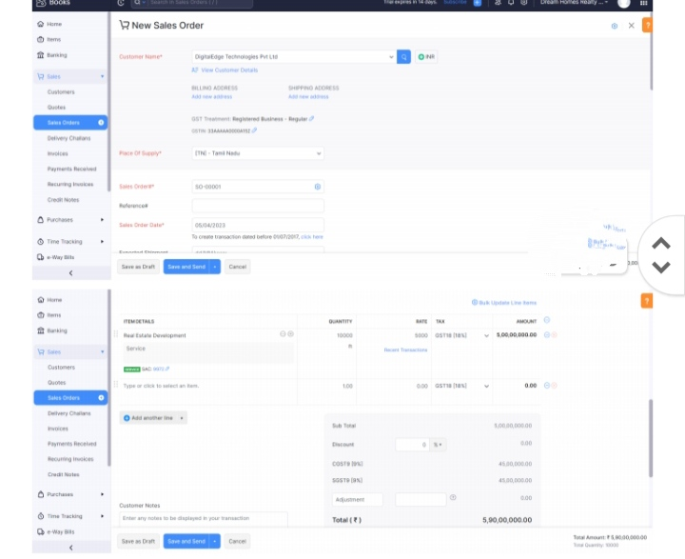

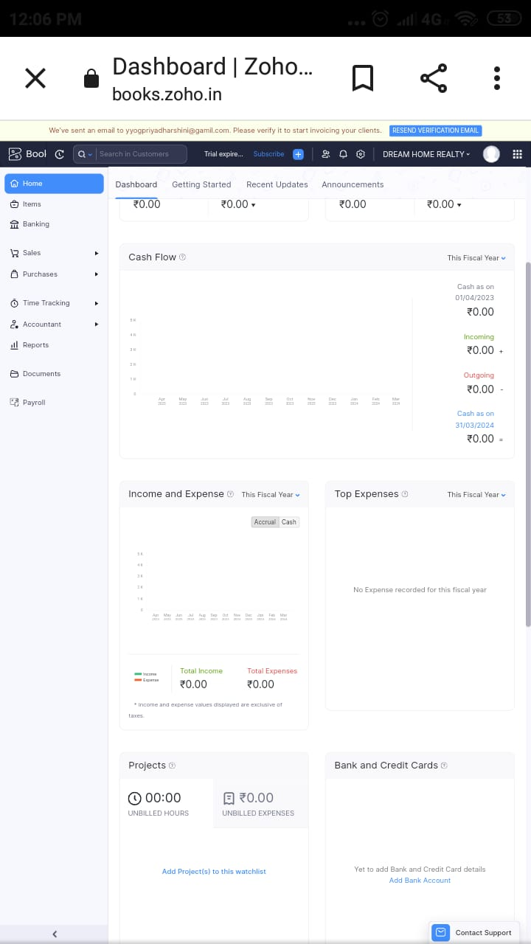

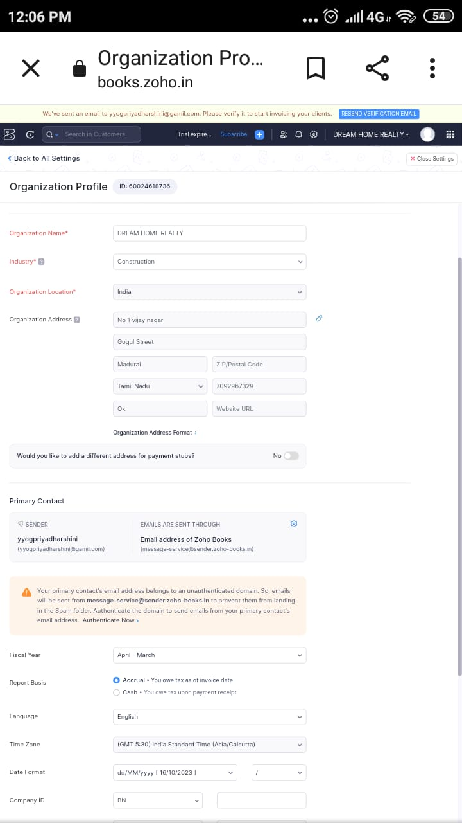

**Conclusion:**

* My dream is to live in a large, independent house surrounded by a large garden filled with flowers and trees. I don't want to live in an apartment building. Rude neighbours make too much noise in the middle of the night sometimes. My dream home would be outside the city where I can find true peace and happiness
* Everyone wants to be successful and rich. I also dream of becoming successful in the field I choose although I am still indecisive about the career path I will choose. But I know whatever I choose I will work hard, stay focused and make it big. I also dream of doing something for my country.

1. **Future scope:**

* The real estate sector is going to continue on its journey of long term growth as we see a continuous rise in GDP per capita, larger disposable incomes, growing urbanization and most of all a larger focus of the world on us as the next big economy
* According to a recent industry report, there will be $1 trillion of real estate sales in India by 2030, contributing 13 per cent to the gross domestic product (GDP) by 2025. Here are some factors behind the massive boom in India's real estate market